EE 546C Lab1

Project Conceptualization

Date: Apr 03
Location: ECE137B

1. Learning Objectives:
- Describe the mechanism of resistive tactile sensing matrix.
- Identify the key steps to realize the tactile sensing system.
- Brainstorm on course projects. Identify the application scenario.

2. Steps:
- Explore how resistive tactile sensors work based on the materials provided during the lab.
- Discuss the project scope with group members and identify the application scenario.
- Prepare the Project Proposal Presentation on April 10.

3. Things you may want to explore:
- Where are the sensing points?
- What is the working principle of a single pressure sensing point?
- How can the pressure changes be detected?
- How to scale up the pressure sensing points？
- How does the signal change based on the size of the electrode?
- What is the limit for spatial resolution?
- How sensitive is the sensor, what is the min/max force it can detect?
- What geometry can the sensors achieve through digital fabrication such as laser cutting?
- How would the signal be serialized? How to read the data from the sensing matrix?

4. Sensor Structure：
(1) The complete sensor consists of a five-layer structure, which we will introduce layer by layer.

The three pieces of conductive fabric shown on the left side of the figure, after being cut, together constitute one layer.

Another layer consists of an entire piece of adhesive tape that was cut to shape. This layer has an adhesive side and a smooth side. It is not conductive. We only use it for its adhesive property.

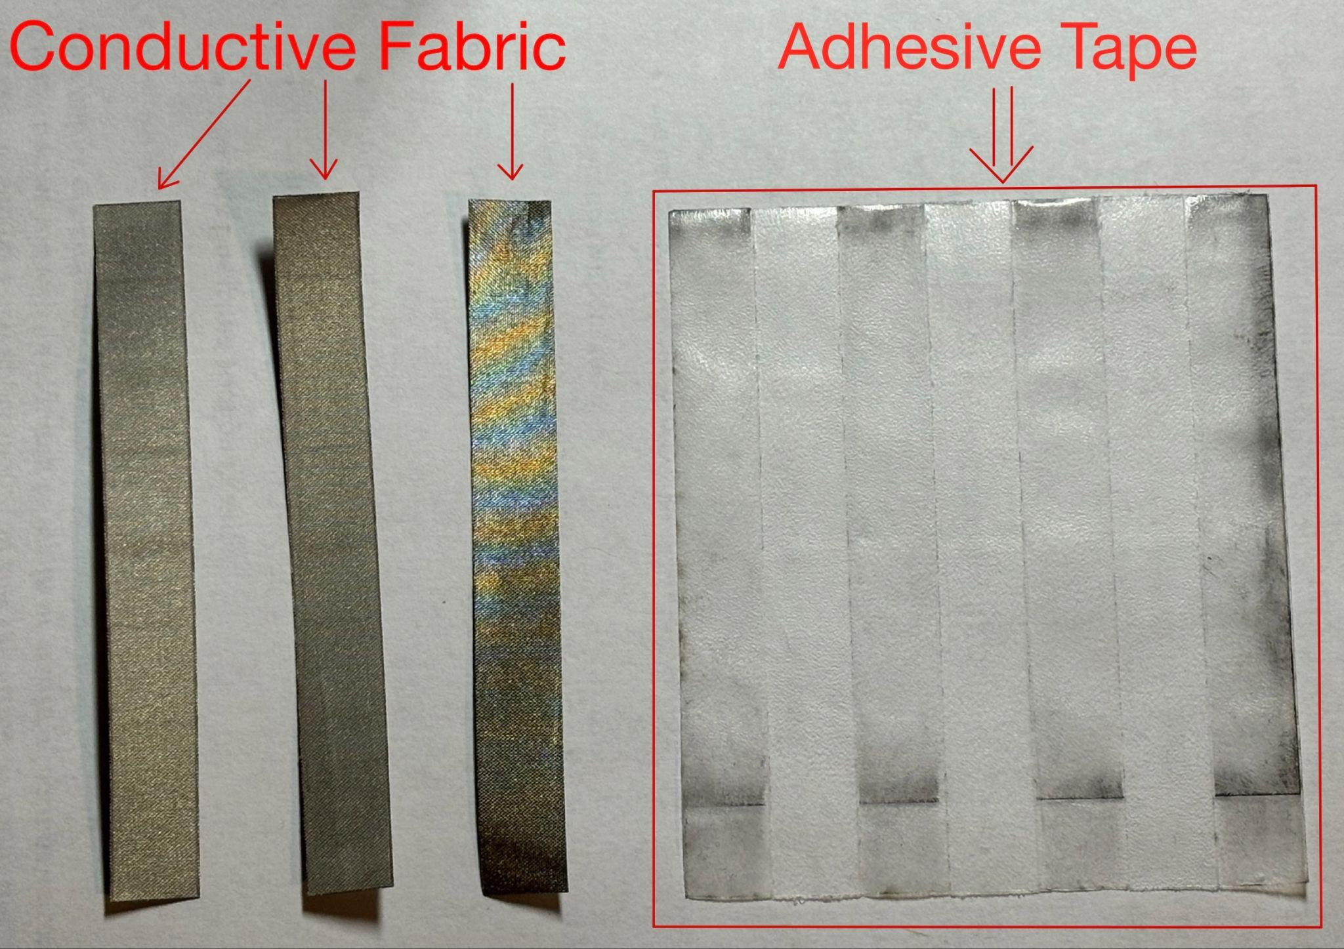

(2) The three conductive fibers are attached to the adhesive side of the tape, forming a two-layer structure.

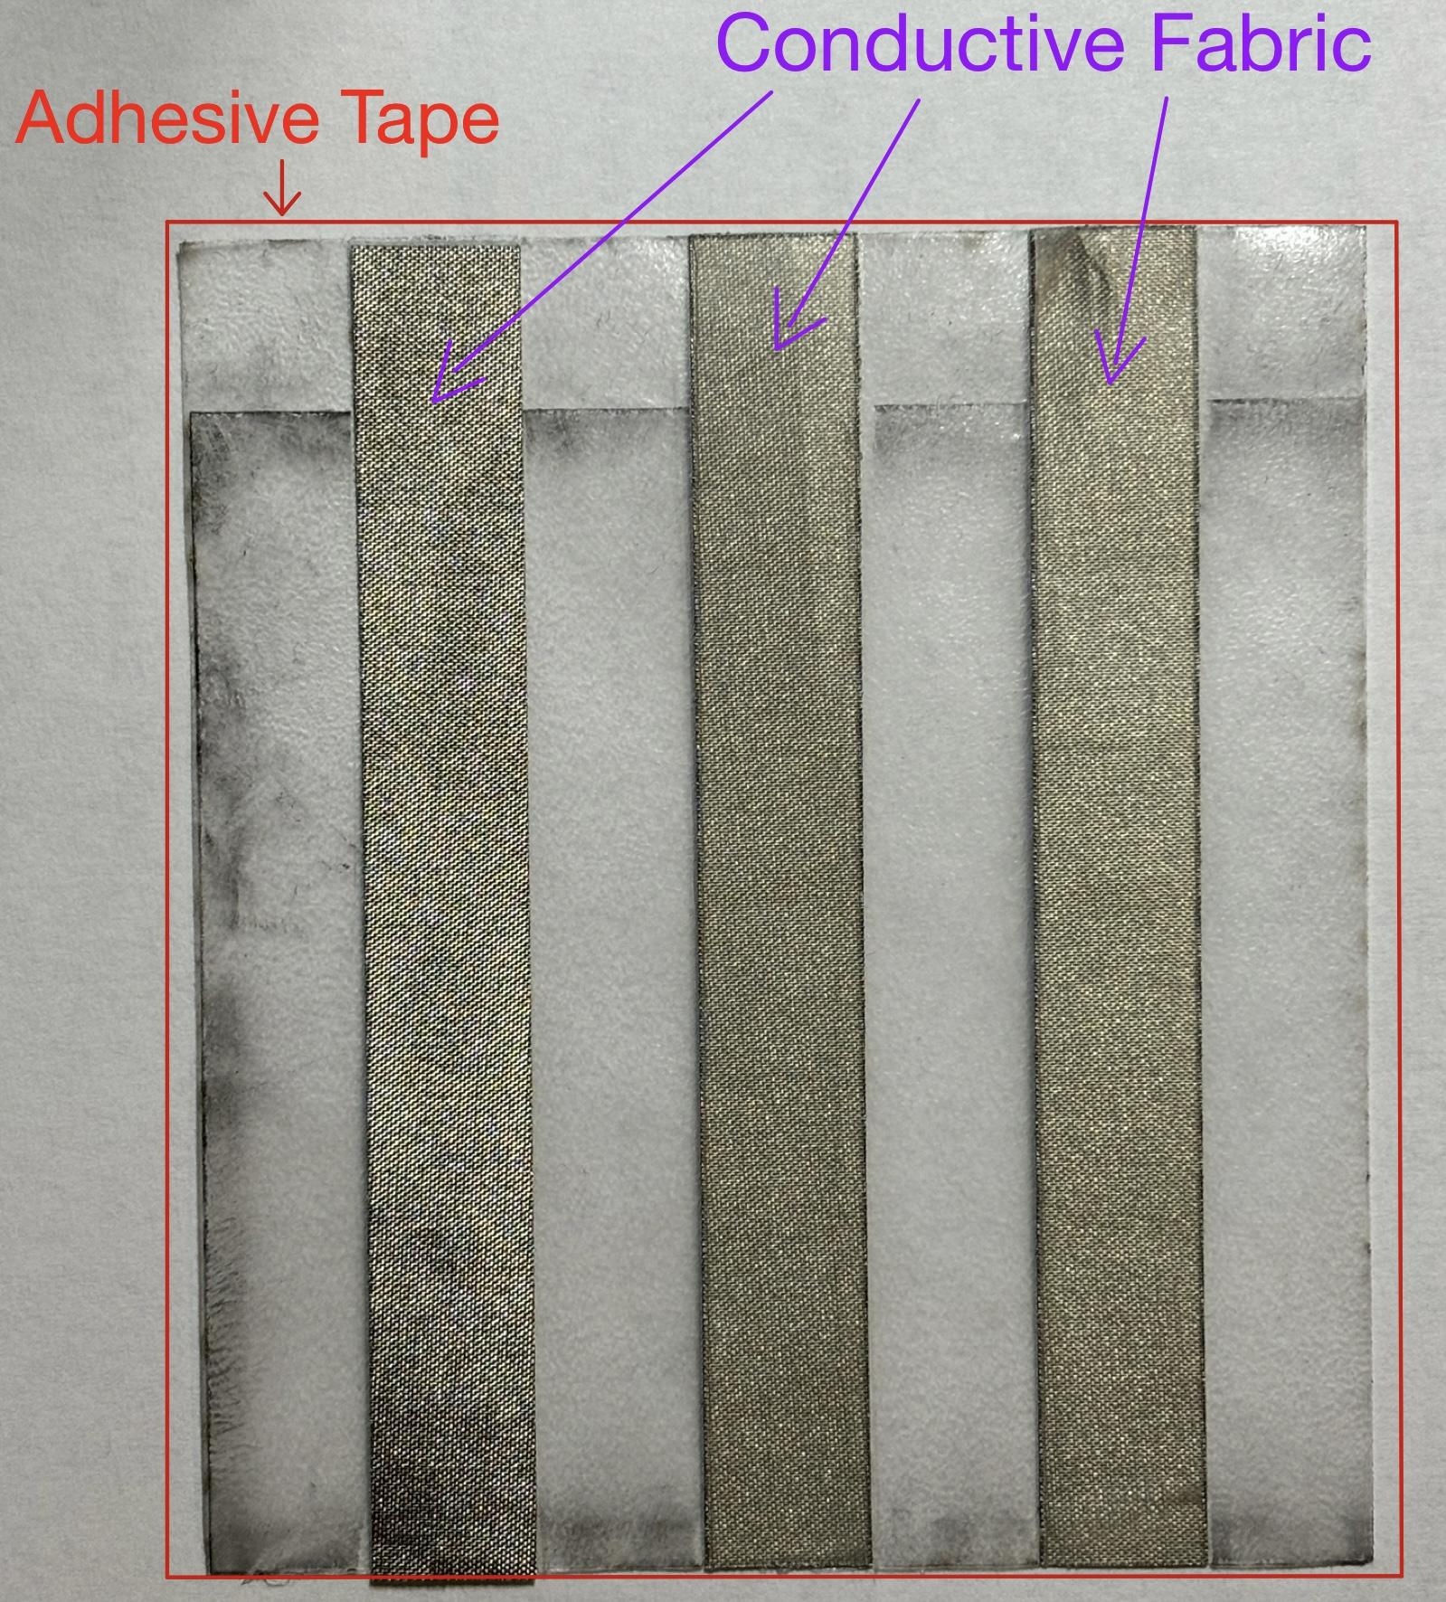

(3) The third layer is a piece of Velostat material that has been cut to shape.

Velostat is a pressure-sensitive conductive polymer film whose resistance decreases as pressure increases. It is composed of a polyolefin film infused with carbon black particles that enable conductivity.

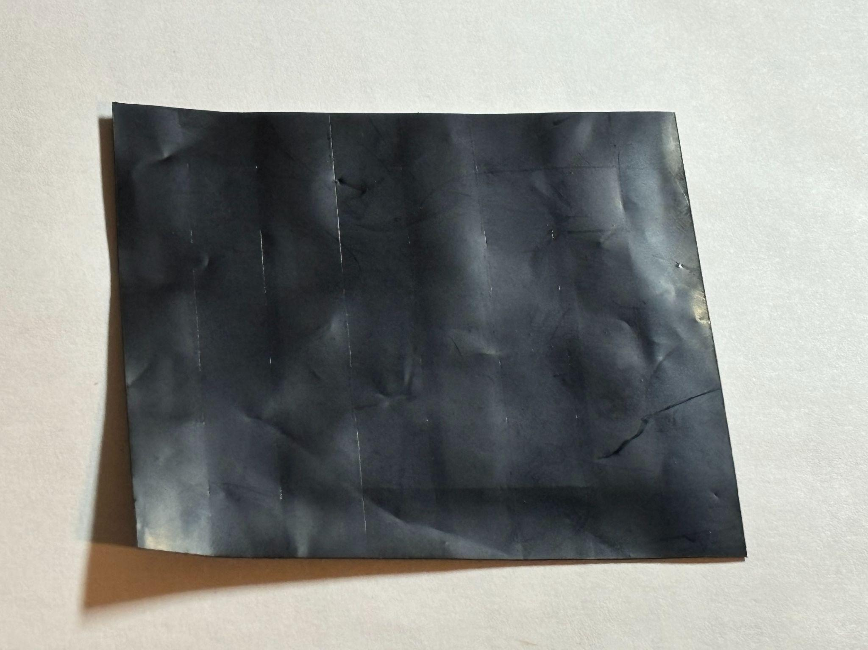

(4) The fourth layer is the same as the second layer (conductive fabric), and the fifth layer is the same as the first layer (adhesive tape).

The five-layer structure resembles a symmetrical sandwich:
First layer: adhesive tape.
Second layer: conductive fabric.
Third layer: velostat sheet.
Fourth layer: conductive fabric.
Fifth layer: adhesive tape.

